**Chapter 1**

**Introduction**

A hotel is an establishment that provides paid [lodging](http://en.wikipedia.org/wiki/Lodging) on a short-term basis. The provision of basic [accommodation](http://en.wikipedia.org/wiki/Lodging), in times past, consisting only of a room with a [bed](http://en.wikipedia.org/wiki/Bed), a [cupboard](http://en.wikipedia.org/wiki/Cupboard), a small table and a washstand has largely been replaced by rooms with [modern](http://en.wikipedia.org/wiki/Modern_history) facilities, including [en-suite bathrooms](http://en.wikipedia.org/wiki/En-suite) and [air conditioning](http://en.wikipedia.org/wiki/Air_conditioning) or [climate control](http://en.wikipedia.org/wiki/Climate_control). Additional common features found in hotel rooms are a [telephone](http://en.wikipedia.org/wiki/Telephone), a wifi connection, an alarm clock, a television, a [mini-bar](http://en.wikipedia.org/wiki/Mini-bar) with snack foods and drinks, and facilities for making tea and coffee. [Luxury](http://en.wikipedia.org/wiki/Luxury) features include bathrobes and slippers, a [pillow menu](http://en.wikipedia.org/wiki/Pillow_menu), twin-sink vanities, and Jacuzzi bathtubs. Larger hotels may provide additional guest facilities such as a restaurant, swimming pool, fitness center, business center, childcare, conference facilities and social function services. Hotel rooms are usually [numbered](http://en.wikipedia.org/wiki/Room_number) (or named in some smaller hotels and breakfast in bed) to allow guests identify their room.

When people go on vacations, they often look for affordable hotel accommodations that provide the amenities they need and want. Accommodations might include free breakfast, a television with cable, hot and cold shower and a wifi connection.

The Tamera Plaza Inn prides itself on cleanliness and superb customer services. Its policy is to consistently provide quality service that meets or exceeds their customer's expectations. The staffs of Tamera Plaza Inn strive to achieve excellence in the industry, and to continually improve the effectiveness of its management system.

* 1. **Project Context**

The proposed Online Hotel Reservation System for Tamera Plaza Inn can enhanced their reservation transaction and their existing website. Making the company attains its goals the system would be a great means of improving the reservation transaction processes of the company. It can make reservation process more accessible to the customers elsewhere. This system can make the flow of reservation operations easier and faster. Thus, this will help company promote their business.

**1.2 Problem Statement**

Based on the gathered data by the researchers, there are problems and difficulties being encountered by the company due to lack of automation with regards to its business reservation transaction. The following are the problems associated with the current operation.

1. The company has an existing website but it was not presented well.
2. The company does not provide an online reservation with their customers thus the company is left behind with technological trend compared to other hotels.
3. Manual reservation and reservation cancelling is time consuming.
4. The company has no prior security between the management and staff with regards to their reservation operations.
5. It is difficult to retrieve customer information and reservation schedules.

**1.3 Objectives of the Study**

This study intends to redevelop an Online Hotel Reservation System that will help the company achieve their goals.

1.3.1 General Objectives:

The system aims to redevelop an Online Hotel Reservation System for Tamera Plaza Inn that will enhance their current website and their reservation transactions.

1.3.2 Specific Objectives:

The following are the specific objectives which have been identified by the researchers during data gathering.

* To redevelop the existing website that goes with the trend of doing business transaction particularly in reservation.
* Create an Online Hotel Reservation System that provides the needs of the online customers.
* Making reservations well situated for the management and customers.
* To augment security between the management and staff with regards to reservation operation.
* To lessen time in retrieving customer information files.

**1.4 Scope and Limitations**

The Online Hotel Reservation System will focus only on the reservation, room availability, room inventory and detailed billing transaction of Tamera Plaza Inn. The computerized system will redevelop their existing website where prospective guest or client can view Tamera Plaza Inn photos of different amenities and rooms offered. It will handle online transaction regarding the reservation.

For the billing, the system will provide a complete calculation of the total charges of the services and amenities availed by the customers, create and print a detailed billing transaction. The system will also include PayPal as online payment.

**1.5 Benefits of the Project**

The result of the study will benefit the Tamera Plaza Inn. The Inn would be adapting the proposed system that would be beneficial to the following stakeholders.

To Carlos Hilado Memorial State College

This study would help the institution to produce more productive students and increase leanings in making a competent system.

To Tamera Plaza Inn

This study will help the business enhance its profitability by attracting more customers through providing suitable services that is right for the customer. It also helps the business by saving time and effort in making decision.

To the End-User

This study will help them make their work more accurate, easier and faster by making the processing of reservation transaction instantly.

To the Customers

This study will help them make the booking transaction easier and faster. It would not take much of their time to wait for the confirmation of the reservation and the information they need about the rooms and amenities because it is available online.

To the Researchers

This study will serve as a tool guide in making an efficient and an improved system.

### To the Future Researchers

### This study would help the future researchers in making their systems which would be serve as their foundation in having a better system.

### To the Info System Department

### This proposed study would be a great means of help to the Information System Department by having this the students and staffs can learn and apply their knowledge to make a proficient system.

**1.6 Definition of Terms**

The following are terms that the researchers identified during the development of the proposed system.

Billing

The amount of [business](http://dictionary.reference.com/browse/business) done by a firm within a specified period of [time](http://dictionary.reference.com/browse/time).

Booker

One who enters accounts or names, etc.

Front Desk

A desk at which a receptionist works in a hotel. Also it is a counter in a hotel at which guests are registered.

Hotel

A [commercial](http://www.businessdictionary.com/definition/commercial.html) [establishment](http://www.businessdictionary.com/definition/establishment.html) providing [lodging](http://www.businessdictionary.com/definition/lodging.html), meals, and other [guest](http://www.businessdictionary.com/definition/guest.html) [services](http://www.businessdictionary.com/definition/services.html). In [general](http://www.investorwords.com/9816/general.html), to be called a hotel, an establishment must have a [minimum](http://www.investorwords.com/10321/minimum.html) of six letting bedrooms, at least three of which must have [attached](http://www.businessdictionary.com/definition/attached.html) (ensuite) [private](http://www.investorwords.com/3850/private.html) bathroom [facilities](http://www.businessdictionary.com/definition/facility.html).

Online

Is the condition of being connected to a [network](http://searchnetworking.techtarget.com/sDefinition/0,,sid7_gci212644,00.html) of computers or other devices. The term is frequently used to describe someone who is currently connected to the Internet.

Reservation

An arrangement by which a hotel room, theater or airline ticket, etc. It is anything so reserved in advance

Room Availability

Electronic reservation system that provides users with current information about a hotel’s available inventory.

Room Inventory

Room inventories are routinely updated for basic data: room number, room use, organization assignment and room area.

Stakeholder

A [person](http://www.businessdictionary.com/definition/person.html), [group](http://www.businessdictionary.com/definition/group.html), or organization that has [direct](http://www.investorwords.com/9451/direct.html) or indirect [stake](http://www.investorwords.com/4681/stake.html) in an organization because it can [affect](http://www.investorwords.com/8782/affect.html) or be affected by the [organization's](http://www.businessdictionary.com/definition/organization.html) [actions](http://www.businessdictionary.com/definition/action.html), [objectives](http://www.businessdictionary.com/definition/objective.html), and [policies](http://www.businessdictionary.com/definition/policy.html). [Key](http://www.investorwords.com/10128/key.html) stakeholders in a [business](http://www.businessdictionary.com/definition/business.html) organization [include](http://www.investorwords.com/9996/include.html) [creditors](http://www.businessdictionary.com/definition/creditor.html), [customers](http://www.businessdictionary.com/definition/customer.html), [directors](http://www.businessdictionary.com/definition/director.html), [employees](http://www.businessdictionary.com/definition/employee.html), [government](http://www.businessdictionary.com/definition/government.html) (and its [agencies](http://www.businessdictionary.com/definition/agency.html)), [owners](http://www.businessdictionary.com/definition/owner.html) ([shareholders](http://www.businessdictionary.com/definition/shareholder.html)), [suppliers](http://www.businessdictionary.com/definition/supplier.html), [unions](http://www.businessdictionary.com/definition/union.html), and the [community](http://www.businessdictionary.com/definition/community.html) from which the business [draws](http://www.businessdictionary.com/definition/draw.html) its [resources](http://www.businessdictionary.com/definition/resource.html).

Website

Is a collection of related [web pages](http://en.wikipedia.org/wiki/Web_page) containing [images](http://en.wikipedia.org/wiki/Image), [videos](http://en.wikipedia.org/wiki/Video) or other digital assets.

**Chapter 2**

**Review of Related Literature**

This chapter discusses about the review of related concepts and the review of related system. This study gives an idea to the researchers in order to have a better understanding to the proposed system. This also serves as a guide to help improve the proposed system.

**2.1 Review of Related Concept**

Online Hotel Reservations Systems commonly known as a central reservation system (CRS) is a web based computerized system that stores and distributes information of a hotel, resort, or other lodging facilities. (Online hotel reservations, 2010)

# Room Availability System is an [electronic](http://www.businessdictionary.com/definition/electronic.html) [hotel](http://www.businessdictionary.com/definition/hotel.html) room-reservation [system](http://www.businessdictionary.com/definition/system.html) that [provides](http://www.businessdictionary.com/definition/provide.html) the latest [information](http://www.businessdictionary.com/definition/information.html) on [accommodation](http://www.businessdictionary.com/definition/accommodation.html) [availability](http://www.businessdictionary.com/definition/availability.html). Another is that room availability is a room present and ready for use, operable, or usable upon [demand](http://www.businessdictionary.com/definition/demand.html) to perform its designated or [required](http://www.businessdictionary.com/definition/required.html) [function](http://www.businessdictionary.com/definition/function.html). It is the [aggregate](http://www.businessdictionary.com/definition/aggregate.html) of the [resource's](http://www.businessdictionary.com/definition/resource.html) [accessibility](http://www.businessdictionary.com/definition/accessibility.html), [reliability](http://www.businessdictionary.com/definition/reliability.html), [maintainability](http://www.businessdictionary.com/definition/maintainability.html), [serviceability](http://www.businessdictionary.com/definition/serviceability.html), and [securability](http://www.businessdictionary.com/definition/securability.html). (Murcko, 2009)

Billing System is a combination of software and hardware that receives call detail and service usage information, groups this information for specific accounts or customers, produces invoices, creates reports for management, and records (posts) payments made to customer accounts. (Althos, 2009)

**2.2 Review of Related System**

Online Reservation System of Circle Inn Hotel

The Online Reservation System of Circle Inn Hotel provides their customer more accessible and effortless way of reservation. The reservation process requires the guest to fill in an online form, mostly the details were already found in their website. (Circle Inn Hotel, 2010)

The East View Hotel Online Reservation System

The East View Hotel also has an Online Reservation System which helps them in their business transactions and operations. Just like the other online reservations it requires the client to fill up the reservation form and the system will be able to identify the room availability at the arrival of the client and if they can be accommodated.

Furthermore, the website provides the basic needs of the customers. And as a result, guests are experiencing satisfaction with the services of the hotel. (East View Hotel, 2012)

The Online Reservation of Fairmont Peace Hotel

The Fairmont Peace Hotel has an Online Reservation System which provides customization for room services like smoking and non-smoking room, bed preferences and rate type like bed & breakfast or Fairmont Savers. Another feature of their system is that it can check the room availability, provides alternative rate if your specified request are available.

There is also a detailed room rate summary for a customer to evaluate the possible charges that they are going to avail.

It also provides reservation details for the customer to view whether the given date of reservation is correct or not. There is also a personal stay preference for the customer to have a convenient and enjoyable stay. (Baldwin, 2011)

Constance Moofushi Resort Maldives Reservation System

Constance Moofushi Resort Maldives also has a system which provides availability calendar which shows the dates of reservation in that particular day, month and year, if it is sold-out, available or if it restricted. It also provides a summary report for a customer to view the possible charges. (Barr, 2012)

Banyan Tree Hotels and Resorts Online Reservation System

Another is the Banyan Tree Hotels & Resorts which provides alternative rate if your specified request are available it also check the room availability and shows reservation details for a customer to evaluate the given reservation. (Jelloun, 2011)

**Chapter III**

**Methodology**

This chapter determines the different procedures of data gathering and the research methods prepared by the researchers in order to establish the fundamentals in the development of an Online Hotel Reservation System. It includes the research approach, system development methodology, system requirements specification, system analysis, data dictionary and the design of the system.

**3.1 Research Approach**

The researcher used the “face to face method” as a strategy known as “interview” where the researchers gathered reliable facts directly from the assigned person within the company. By personal communication it is possible not only to obtain more information but also to encourage response. A face-to-face interview does not bore a respondent hence ensures full and accurate data.

**3.2 Systems Development Methodology**

Based on the study of (Kendall, 2002) the researchers used Kendall and Kendall’s System Development Life Cycle (SDLC) method. It is the process by which an Information System comes to life and maintains its usefulness to a business as it moves from inception to replacement. The following are the steps followed by the researchers to come up with the system.

Identify problems, opportunities, and objectives

The researchers search for an organization for conducting a study. The researchers choose Tamera Plaza Inn to investigate their processes such as making an Online Hotel Reservation System. Determining the problems occurred regarding with their manual processes of transactions and difficulties in reservation.

The researchers come up with the objectives to create a system that will help the organization with regards to their problems in their reservation.

Determine the information required

The researchers formulated questions related to the information that will be needed in creating the Online Hotel Reservation System through interviews.

Analyze system needs

The researchers analyzed the data that are being gathered. Know the ins and out of the processes. Through data gathering, the researchers had examined and study the situation that leads them to develop an Online Hotel Reservation System for Tamera Plaza Inn.

Design the recommended system

The researcher has now a better look what the system looks like, what are the needed inputs and possible outputs. The researchers visualized the system by creating the blueprint of the system.

Such as the entity relationship, database structures and creating a presentable system design in which the proponents have undergone intensive problems. System requirements such as the hardware and software are being cited in this stage.

Develop and document the software

The researchers build the Online Hotel Reservation system. Create the documents needed to support the system. Databases and programs are built in to materialize the plan.

Test and maintain the System

The researchers tried to test whether the system is running properly and whether it suits the organization needs. If not, improvements are needed until objectives are totally met. Maintaining the system is needed by keeping the system up to date with the changes in the organization.

The researchers ensure that the system meets the goals of the organization.

Implement and evaluate the system

The system is now put into real action by using it in its intended usage. It is being used by the user such as the staff.

Evaluate whether there is a need for improvement or not. Users are given procedures on how to operate the system properly.

**3.3 System Requirement Specification**

Functional Requirements

The online hotel reservation system is a system that will initially address the Tamera Plaza Inn’s online reservation need.

Potential customers can make an online reservation elsewhere. The system is user friendly for the online customers and as well as for the hotel personnel. Among others the online hotel reservation system will have the following functionalities:

Check Availability

* Arriving Date
* Departing Date

Rooms & Rates

* Type of room
* Room rate summary
* Rate type
* Adults per room
* Children per room

Customer Information

* Personal Details
* First Name
* Last Name
* Address
* City
* Postal/Zip code
* Country
* State/Province
* Email Address
* Contact Number
* Room Details
* Room type
* Room description
* Room rate

Input Requirements (Guest)

Check-In and Check-Out Date

Potential customers are required to input their arrival and departure date so that the system can checked whether the date they want to stay is available or not. The system can also be able to suggest what room types are available in that particular time duration.

Input Requirements (Admin/ Front Desk)

User Name and Password

Each user is assigned with a unique user name and password in making an access to the system. This user name and password is recorded in the database to monitor the individuals who interact with the system in that period.

Output Requirements (Guest)

Transaction Summary and Confirmation

Each online customer must have a view of summary of actions done for a particular session or a particular reservation function. The online system database will be able to display all successfully committed transactions.

Output Requirements (Admin/Front Desk)

View Total Reservation Request and Generate Reports

The online hotel reservation system can generate reports such as daily and detailed billing reports. The admin can also view the reservation request of the customers in a particular period.

Software Requirements

In this phase of improvement of the proposed system, the following are the software requirements which will be used by Tamera Plaza Inn.

Operating System: Windows XP / Windows 7

Applications: Web Browser (Mozilla Firefox, Google Chrome or Internet Explorer)

The researchers used PHP (Hypertext Pre-processor) as a front-end for designing and enhancing of the system. For the back-end, MySQL Server for storing reservation records, customer’s information and detailed billing records in reservation. This program is more consistent and easy to use by the users. The software used by the researchers in the development was recommended to the organization. The researchers believe that the software recommended can surely help the needs of the company for faster operation.

Hardware Requirements

In this part of the study, the following are the minimum and the recommended hardware devices to be used by the management in the progress of the system.

Minimum

Processor: Intel Pentium III

Memory: 1GB

Hard Disk: 40 GB Hard Disk Drive

Monitor: Any Colored Monitor

Mouse: Any Optical Mouse

Printer: Any Compatible Printer

Storage Devices used for Back-up: Any USB Mass Storage Devices

Recommended

The following are the list of hardware devices which will be used by the management to support the functions and the executions of the proposed system.

Processor: Intel Core or Higher

Memory: 2 GB RAM or Higher

Hard Disk: 80 GB Hard Disk Drive or Higher

Storage Devices used for Back-up: 80 GB USB Mass Storage Devices

**3.4 System Analysis**

Nowadays online services are being in demand due to the development of new technology. Businesses who provides online are the one who takes the lead in the market.

This study is developed for Tamera Plaza Inn in response to their need of enhancing their reservation process; detailed billing when it comes to their online reservation transaction and to redevelop their existing system and to make it more enticing on the web.

Based on the information gathered by the researchers they were able to come up with the common ways of making reservation system to be developed online and find solutions to the existing problems being encountered by the business. The system would be based on the reservation form that will be given to the potential customers online.

The researchers design a system that will handle all the details in developing an online reservation system which includes the customer’s information, reservation availability and detailed billing charges. This will include a password-protected database for administrator.

Data Dictionary

The following tables below show the fields of their respective entities. The tables presented the relationship of the data that are being gathered during the observation and interview. The following are the data which are used by the researchers in the development of the system. Each table shows the attributes according to their description, field name, and field type and field size.

The User table contains user id, password and username of the guest who entered information. This table also shows the field type, length of field and its description.

Table 1. User

|  |  |  |  |  |  |
| --- | --- | --- | --- | --- | --- |
| **Field Name** | **Optional** | **Field Type** | **Length** | **Key** | **Description** |
| Userid | N | Auto | 10 | PK | User id of guest who entered information |
| Password | N | Varchar | 10 |  | Unique password of the assigned person |
| Username | N | Varchar | 30 |  | Username of personnel who entered information |

The comment table shows the comment id, name of customer, email address and content of the message. It also shows the description of fields, field type and length of fields.

|  |  |  |  |  |  |
| --- | --- | --- | --- | --- | --- |
| **Field Name** | **Optional** | **Field Type** | **Length** | **Key** | **Description** |
| comment_id | N | Auto | 30 | PK | Comment ID of guest who wants to comment |
| Name | N | Varchar | 30 |  | Name of customer |
| Email | N | Varchar | 30 |  | Email Address of customer |
| Content | N | Text |  |  | Content of the message |

Table 2. Comment

Table 3 on page 21 is composed of field name which are the arrival date, departure date, number of child, number of adult, room id, room type, room rate, first name, last name, address, city, email address, country, contact number, number of nights and total amount of payment. This table also shows the field type, length of field and its description.

Table 3. Reservation

|  |  |  |  |  |  |
| --- | --- | --- | --- | --- | --- |
| **Field Name** | **Optional** | **Field Type** | **Length** | **Key** | **Description** |
| reservation_id | N | Auto | 10 | PK | Reservation Id of the guest who entered the information |
| firstname | N | Varchar | 100 |  | Fist name of guest who entered information |
| lastname | N | Varchar | 100 |  | Last name of guest who entered information |
| city | N | Varchar | 100 |  | City Address of guest who entered information |
| zip | N | Int | 10 |  | Zip code of guest who entered information |
| province | N | Varchar | 30 |  | Province of guest who entered information |
| country | N | Varchar | 100 |  | Country of guest who entered information |
| email | N | Varchar | 100 |  | Email Address of guest who entered information |
| contact | N | Int | 30 |  | Contact number of guest who entered information |
| username | N | Varchar | 30 |  | Username of the guest who entered the info. |
| password | N | Varchar | 30 |  | Password of the guest who entered the information |
| arrival | N | Date | 10 |  | Arrival date of the guest who entered the information |
| departure | N | Date | 10 |  | Departure date of the guest who entered the information |
| adults | Y | Int | 5 |  | Number of adult(s) who will avail the accommodation |
| child | Y | Int | 5 |  | Number of child/children who will avail the accommodation |
| result | N | Int | 10 |  | Result of the number of nights |
| room_id | N | Int | 5 | FK | Room id of the guest who entered information |
| no_room | N | Int | 5 |  | The number of room(s) the guest wants to book |
| payable | N | Int | 10 |  | The total amount to be paid |
| confirmation | N | Varchar | 7 |  | The confirmation code given to the guest |

In this table it contains room id, room type, room rate, description of room, room image, room quantity maximum child and adult. It also shows the field type, length of field and field description.

|  |  |  |  |  |  |
| --- | --- | --- | --- | --- | --- |
| **Field Name** | **Optional** | **Field Type** | **Length** | **Key** | **Description** |
| room_id | N | Auto | 30 | PK | Room id of the guest who entered the information |
| type | N | Varchar | 50 |  | The type of room offered |
| rate | N | Int | 10 |  | The price of the corresponding room |
| description | N | Text |  |  | The description of the room being offered |
| image | N | Int | 100 |  | Room image |
| max_adult | N | Varchar | 5 |  | Maximum Adult per room |
| max_child | N | Varchar | 5 |  | Maximum Child per room |

Table 4. Room

In this table it contains room inventory_id, arrival, departure, qty_reserve, room_id, confirmation, status. It also shows the field type, length of field and field description.

|  |  |  |  |  |  |
| --- | --- | --- | --- | --- | --- |
| **Field Name** | **Optional** | **Field Type** | **Length** | **Key** | **Description** |
| Room_inventory_id | N | Auto | 10 | PK | Inventory Id of the room |
| arrival | N | Varchar | 30 |  | The arrival date of the guest who entered the information. |
| departure | N | Varchar | 30 |  | The departure date of the guest who entered the information |
| qty_reserve | N | Int | 11 |  | The number of room(s) being occupied |
| room_id | N | Int | 10 | FK | The room id of the room |
| confirmation | N | Varchar | 30 |  | Confirmation number |

Table 5. Room Inventory

In this table it contains payment id, name of item, number of item, status, currency, txn_id and the payer’s email. It also shows the field type, length of field and field description.

Table 6. Payment Notification

|  |  |  |  |  |  |
| --- | --- | --- | --- | --- | --- |
| **Field Name** | **Optional** | **Field Type** | **Length** | **Key** | **Description** |
| pay_id | N | Auto | 10 | PK | The pay id of the guest |
| item_name | N | Varchar | 100 |  | The name of the item |
| item_number | N | Int | 100 |  | The number of item being acquired |
| status | N | Varchar | 100 |  | The status of payment |
| amount | N | Int | 100 |  | The total amount to be paid |
| currency | N | Varchar | 100 |  | The form of payment the guest is going to pay e.g dollar/peso |
| txn_id | N | Int | 100 |  | Transaction id |
| payeremail | N | Varchar | 100 |  | The email address of the guest |

**3.5 Design**

In this chapter, it shows some figures or the graphical and symbolic representation of the process which will be undertaken by the system. These symbols are linked together with arrows showing the process flow direction.

NO

LOG-IN

User Name &

Password

Yes

Home Page Admin

View Comments

View and Monitor Reservation

Edit Hotel

Amenities

Add Hotel

Amenities

Delete Room

Type

Edit Room Type

Add Room

Type

Generate Report

Figure 1. System Flowchart for Administrator

The Online Hotel Reservation System shows the system flowchart for admin. First, the admin will log-in to the system wherein it requires username and password if the required inputs are invalid it will go back to the log-in page. If the inputs are true it will display the homepage wherein the admin can add, edit and delete room type. The admin can also add and edit hotel amenities, can view reservations, view guest comments and generates report.

LOG-IN

User Name &

Password

NO

YES

Home Page Admin

View and Monitor Reservation

View Comments

Generate Report

Figure 2. System Flowchart for Front Desk

The Online Hotel Reservation System shows the system flowchart for front desk. First, the front desk will log-in to the system wherein it requires username and password if the required inputs are invalid it will go back to the log-in page until it is true. If the required inputs are true then the front desk can access the home page, can monitor reservations, view guest comments and generate report.

Receive Confirmation Number

Make Online Payment

Input Customer Information

Check Room Availability

Select Room Type

Figure 3. System Flowchart for New Guest

This figure shows the system flowchart for new guest. The guest can check availability of rooms for reservations, select room type and input guest information for having an online payment which is pay pal. The system automatically sends confirmation number to the guest for the confirmation of reservation processes.

Check Room Availability

Email address & Password

LOG-IN

Select Room Type

NO

YES

Make Online Payment

Figure 4. System Flowchart for Old Guest

The figure above shows the system flowchart for old guest. The guest can check available room and select types of room for reservation. By having an existing account the guest can log-in their email address and password. If the inputs are true then the guest can make an online payment.

Monitor and View Reservation

Reservation Inquiry

0

Online Hotel Reservation System

Customer Confirmation Number

**FRONT DESK**

Reservation and Detailed Billing Reports

**GUEST**

**ADMIN**

Figure 5. Context Diagram

This figure shows the Context Diagram of Online Hotel Reservation System for Tamera Plaza Inn. This identifies the entities that the researchers used for interaction between the systems. The Context Level Diagram is a structured design which shows the flow of data. The entities are guest, the front desk and the admin, they are the one which will be using the system.

A context diagram is a data flow diagram, with only one massive central process that subsumes everything inside the scope of the system. It shows how the system will receive and send data flows to the external entities involved. This are [diagrams](http://en.wikipedia.org/wiki/Diagram) used in [systems design](http://en.wikipedia.org/wiki/Systems_design) to represent the more important external factors that interact with the system at hand.

Room Info

D2 Room Records

1.1.1

Update Room Type

Admin

Verify Username and Password

D4 Reservation

Records

1.1.2

Monitor

Reservation

Reservation

Info

1.0

Log In

Comment

D5 Comment

Records

1.1.3

View Comment

D1 Admin Records

1.1.4  
Generate Detailed Billing Report

Billing Info

Figure 6. Explosion 0 for Administrator

The figure shows the Explosion 0 for Administrator, the admin will log-in to the system which requires username and password wherein the input information will be stored at the admin records. After that, if the admin would have an access he/she can update room type, monitor reservation process, view guest comments and generate detailed billing report of the guest reservations.

Verify Username and Password

1.0

Log In

D1 Admin Records

Front Desk

Correct Username and Password

1.1.1

View/Monitor

Reservation

1.1.2

View Guest Comment

1.1.3

Generate Detailed Billing Report

Reservation

Information

D4 Reservation Records

D4 Reservation Records

Comments

D5 Comment Records

Figure 7. Explosion 0 for Front Desk

This figure shows the explosion 0 for front desk. The front desk will log-in to the system which requires username and password. If the inputs are valid the front desk can monitor reservations information, view guest comments from the comment record and detailed report from the reservation records.

Guest

1.0

Enter Check In/Out Date

D4 Reservation Records

Room Type Data

1.1

Select Room Type

D2 Room Records

Receive

Confirmation

Detailed Customer

Information

Customer Information

1.2

Enter Customer Information

Payment

Payment Details

1.3

Make Online Payment

D6 Payment Records

1.4  
Receive Confirmation Number

Confirmation Number

Figure 8. Explosion 0 for New Guest

Figure 8 shows the explosion 0 for new guest, the guest will enter reservation dates and select room types from the room records. After that, the guest will enter detailed information in making an online payment. Lastly, the guest will receive confirmation number of their reservation process from the reservation records.

Guest

1.0

Enter Check In/Out Date

D4 Reservation Records

Room Type Data

1.1

Select Room Type

D2 Room Records

Detailed Customer Information

Receive

Confirmation

Validate

1.2

Log-In Information

Payment

Payment Details

1.3

Make Online Payment

D6 Payment Records

Confirmation Number

1.4  
Receive Confirmation Number

Figure 9. Explosion 0 for Old Guest

This figure shows explosion 0 for old guest wherein the guest will enter reservation and can select room types. The guest will log-in username and password to validate guest information for making an online payment. After that the guest will receive confirmation number from the reservation records for the process of reservations.

**Comment**

PK comment_id

name

email

content

**User**

PK userid

username

password

position

**Payment Notification**

PK pay_id

item_name

amount

item_number

status

currency

txn_id

payer_email

contain

**Room**

PK room_id

type

rate

description

image

max_adult

max_child

**Reservation**

PK Reservation_id

firstname

lastname

city

zip

province

country

email

contact

userrname

password

arrival

departure

adults

child

result

room_id

no_room

payable

status

confirmation

contain

has

**Roominventory**

PK roominventory_id

arrival

departure

qty_reserve

FK room_id

confirmation

status

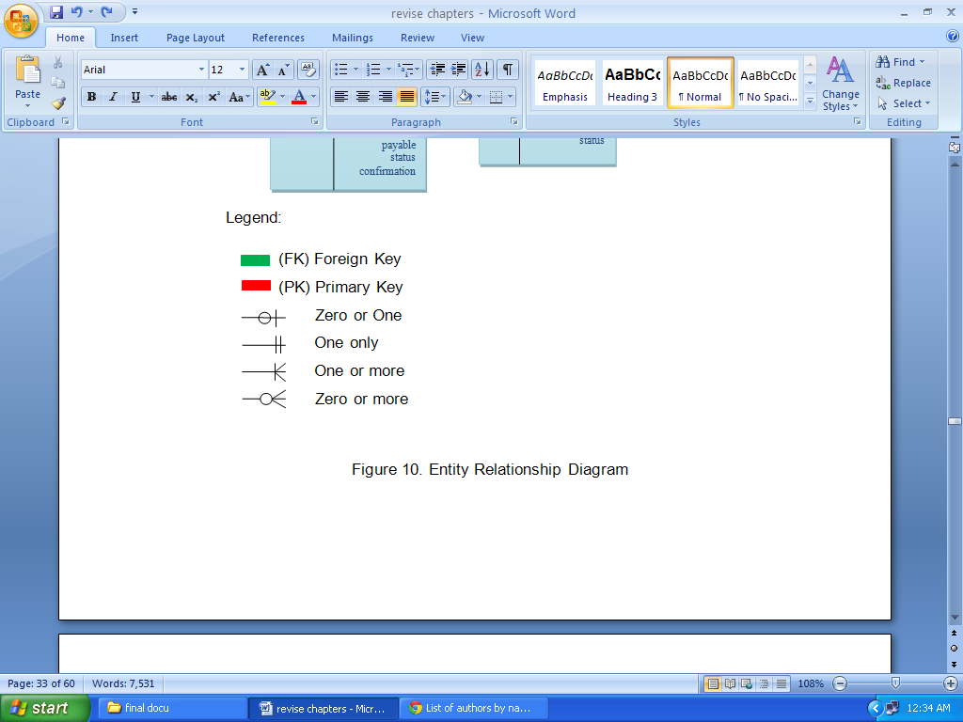

Figure 10. Entity Relationship Diagram

This figure shows the Entity Relationship Diagram of Online Hotel Reservation System for Tamera Plaza Inn.



Administrator

Figure 11. Use Case Scenario for Admin



Front Desk

Figure 12. Use Case Scenario for Front Desk



New Guest

Figure13. Use Case Scenario for New Guest



Old Guest

Figure 14. Use Case Scenario for Old Guest

**Chapter IV**

**Technical Background**

The existing system used by Tamera Plaza Inn in handling reservation is the traditional manner of scheduling reservations. This study merely focuses on developing an Online Hotel Reservation System and this will be use in the reservation transaction of Tamera Plaza Inn. The gathered data shall be crucial components in developing the proposed system. The computerized system will redevelop their existing website where prospective guest or client can view Tamera Plaza Inn photos of different amenities and rooms offered. It will handle online transaction regarding the reservation. For the billing, the system will provide a complete calculation of the total charges of the services and amenities availed by the customers, create and print a detailed billing transaction. The system will also include PayPal as online payment.

**4.1 Major Software Functions**

In this phase of improvement the main function of the Online Hotel Reservation System is to enable guests to reserve rooms directly via internet once they have confirmed availability of rooms in accordance with their itinerary schedule. This system makes the reservation process computerized and thus helps guests to undertake a large amount of transactions at a low cost. It enables guest to complete an online booking form making the reservation process more efficient and less time consuming. The management can resourcefully manage and monitor the hotel reservation. Online Hotel Reservation System assists guests with different payment options such as paypal.

**4.2 Performance Issues and Management**

In this point the researchers designed and develop a system that would be compatible on any higher processor to provide the system with adequate memory to secure its availability.

The system performance depends on its hardware and software specification to ensure that the system will run and execute accurately.

**4.3 System’s Testing**

In this phase the system is tested, the Online Hotel Reservation System properly running according to the requirements and a complete analysis has been done, the said system is ready to be used.

**4.4 System’s Evaluation**

The System Evaluation Form was conducted in order to assess the overall function of Online Hotel Reservation System to be used by the Tamera Plaza Inn. The management and users were asked to participate in System Evaluation Form survey.

The System Evaluation Form was used as one of the data gathering instrument for this study (See Appendix B). The questionnaire composed of twenty four criteria using McCalls’ software quality standards.

The main purpose of the questionnaire is to assess the overall function of the system. The questions were structure using the Likert format.

In this questionnaire, five choices are provided for every criterion. The choices represent the degree of agreement each respondent has on the given question.

The scale on the next page was used to interpret the total responses of all the respondents for every survey question by computing the weighted mean:

Mean Range Interpretation

4.50 – 5.00 Very High

3.50 – 4.49 High

2.50 – 3.49 Average

1.50 – 2.49 Low

0.50 – 1.49 Very Low

The Likert survey was the selected questionnaire type as this enabled the respondents to answer the survey easily. In addition, this research instrument allowed the research to carry out the quantitative approach effectively with the use of statistics for data interpretation.

The respondents as well as their answers were not part of the actual study process and were only used for assessing the system. After the questions have been answered, the proponent asked the respondents for any suggestions or any necessary corrections to ensure further improvement and validity of the system.

Table 7. System’s Evaluation Form Criteria

|  |  |  |
| --- | --- | --- |
| **Criteria** | **Mean Range** | **Interpretation** |
| 1. Auditability – keeping the record of standard so that you can locate the origin of specific features that appears on reports. |  |  |
| 2. Accuracy – meeting the user’s need and having a clear statement of what is required. |  |  |
| 3. Commonality – the degree to which standard, interfaces, protocols and bandwidth are used. |  |  |
| 4. Completeness – building a representation of requirements that can be accessed of correctness and consistency. |  |  |
| 5. Conciseness – the compactness of the programs in terms of line of code. |  |  |
| 6. Consistency – a sound structure which is free from logical defects. |  |  |
| 7. Observability – system states and variables are visible or queriable during execution, all factors affecting the output is visible. |  |  |
| 8. Operability – the ability of the system to operate with almost no downtime. |  |  |
| 9. Security – referring to the availability of mechanism that control or protect programs and data. |  |  |
| 10. Self-Documentation – as the degree to which the source code provides meaningful documentation. |  |  |
| 11. Simplicity – the degree to which the program can be understood with less difficulty. |  |  |
| 12. Software System Independence – degree to which the program is independent of nonstandard programming language features, operating systems characteristics, and other environmental constraints. |  |  |
| 13. Traceability – the ability in tracing a design representation or actual program component back to requirements. |  |  |
| 14. Training – as the degree to which the software assists in enabling new users to apply the system. |  |  |
| 15. Controllability – defined as an exercise of authority or dominative influence. |  |  |
| 16. Data Commonality – an attribute of the software that provides the use of standard data representations and structures. |  |  |
| 17. Decomposability – as a large entity separated into component or basic units. |  |  |
| 18. Error Tolerance – the ability of the system to repair any damage data. |  |  |
| 19. Exception Efficiency – an attribute of software that provides for minimum execution processing time without decrease in functionality. |  |  |
| 20. Expandability – the degree to which the system can be modified or improved. |  |  |
| 21. Generality – the breadth of potential application of program components. |  |  |
| 22. Hardware Dependence – having a free hand over the way in which the system is implemented. |  |  |
| 23. Instrumentation – user defined functions which the agent calls at a different time. |  |  |
| 24. Modularity – a mechanism for splitting software into dependent modules and grouping together items that have some mutual affinity. |  |  |

After gathering all the completed System Evaluation Form from the respondents, total response for each item was obtained and tabulated. In order to use the Likert-scale for interpretation, weighted mean to represent each criteria was computed.

Weighted mean is the average wherein every quantity to be averages has a corresponding weight. These weights represent the significance of each quantity to the average. Above table are the interpretations for every criteria:

Table 7 which is the System’s Evaluation Form Criteria shows High interpretation. The overall assessment in terms of Mean Range is 4.17 or equivalent to High. This means that the system is feasible to be used for Tamera Plaza Inn.

**4.5 System Interface Description**

In this section shows the actual screen lay-out of the system. This form shows the process on the how system flows. The forms are used to display content available only to the specific page. This part can also be used to display a general application error message if the web site is unavailable. The interface design is to make the user's interaction as simple and efficient as possible, in terms of accomplishing user goals.

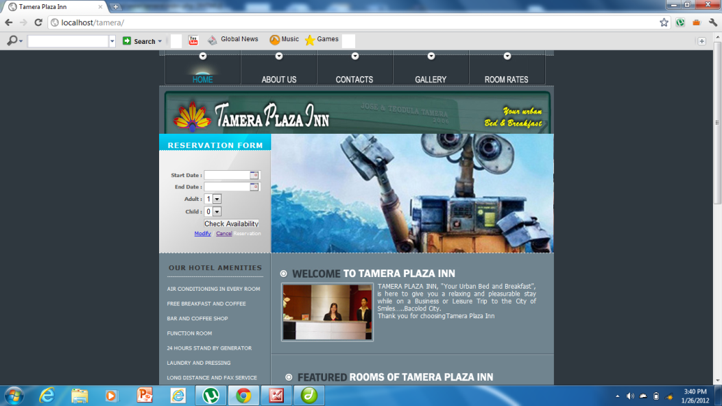

Figure 15. Main Form

This figure shows the main form of Online Hotel Reservation System it shows the availability calendar which the guest can select their desired dates to book. The figure also shows the number of maximum adults and child’s that will be staying.

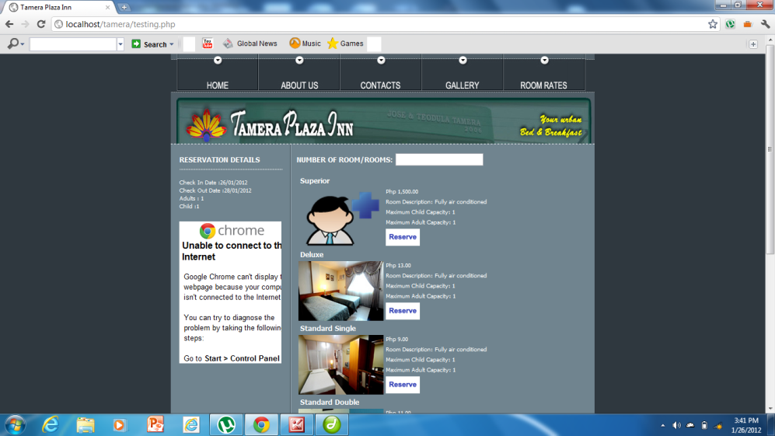

Figure 16. Select Room

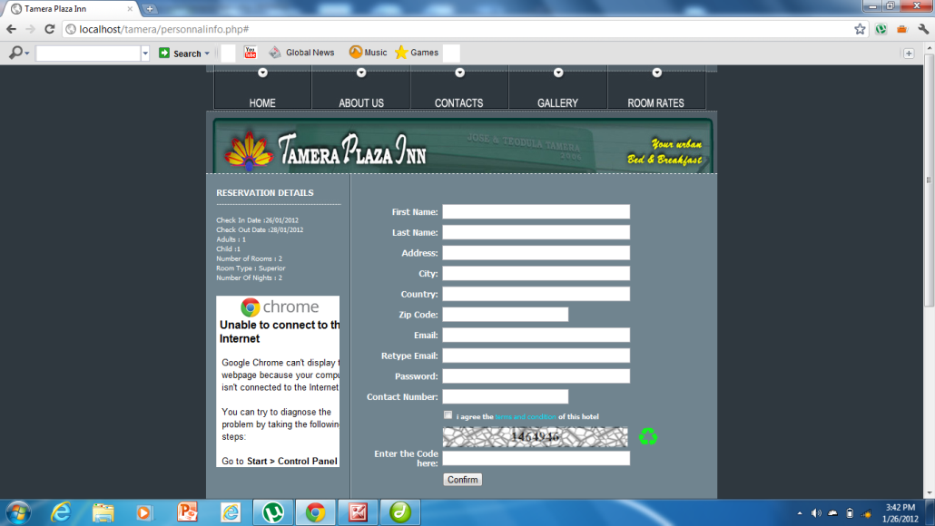 This figure below shows number of rooms available in each type and rate of the room. Another is that the guest can indicate number of rooms they want to acquire. At the side the customer can check out or view their reservation details.

Figure 17. Guest Information

This figure shows the information details of a guest. If the guest has an existing account he/ she can login to retrieve the files.

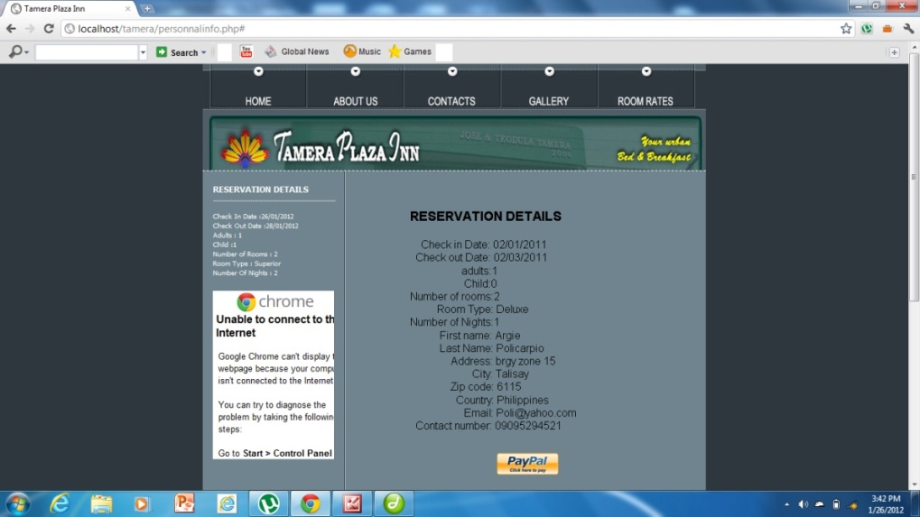

Figure 18. Payment

This figure shows the payment details of the customer.

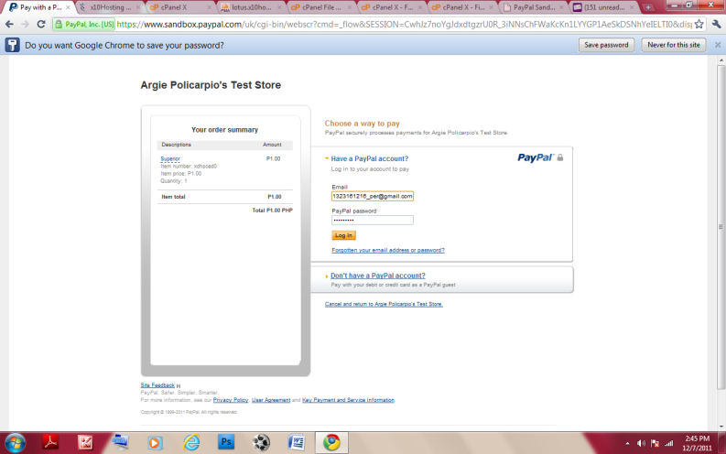

Figure 19. Login PayPal

The figure shows the login page for PayPal which require guest to input their email address and password and also indicates payment methods.

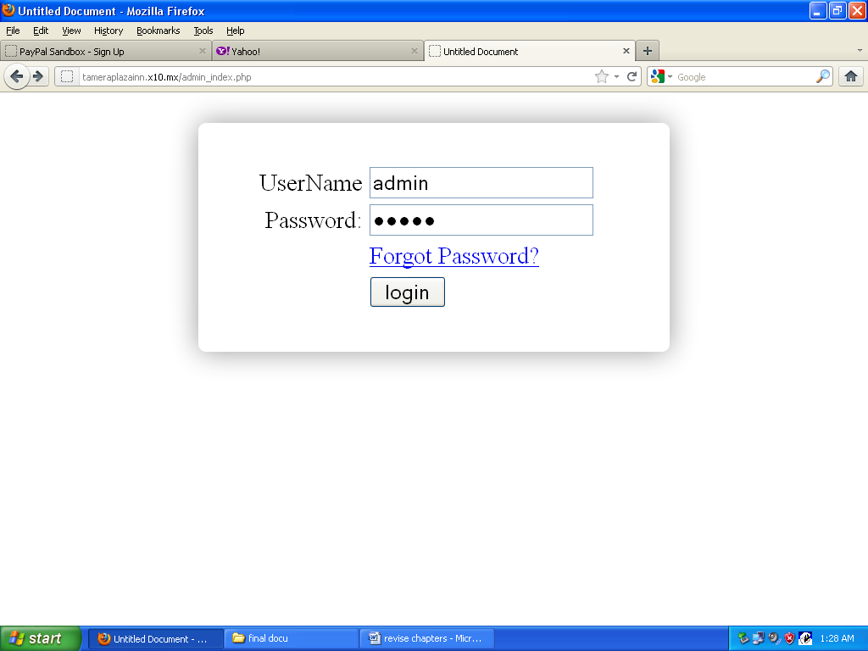**Administration Form**

Figure 20. Log In Form for Admin

This form shows the log in form for admin which indicate the username and password.

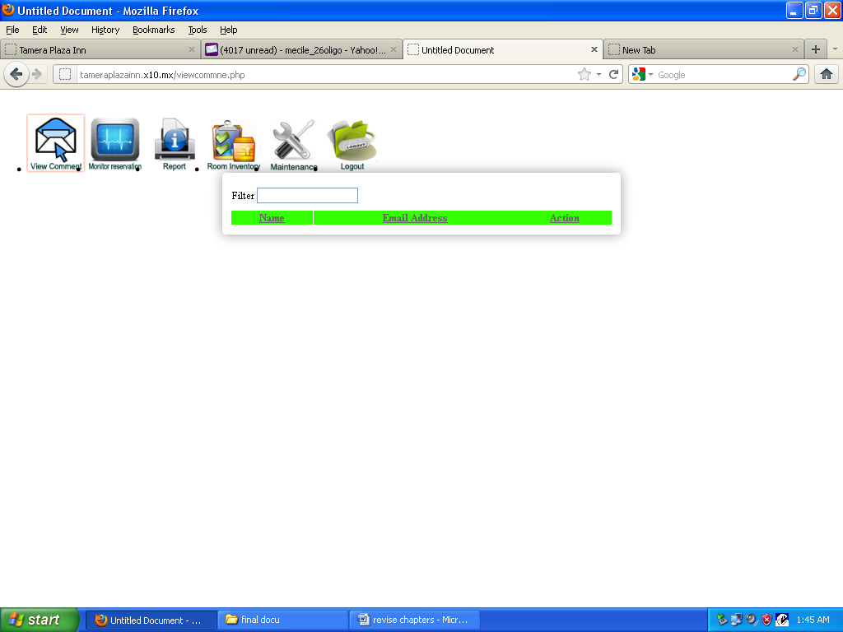

Figure 21. Guest Comments

This part shows the comments and suggestions of the guest.The adminstrator can read the comments of their guest.

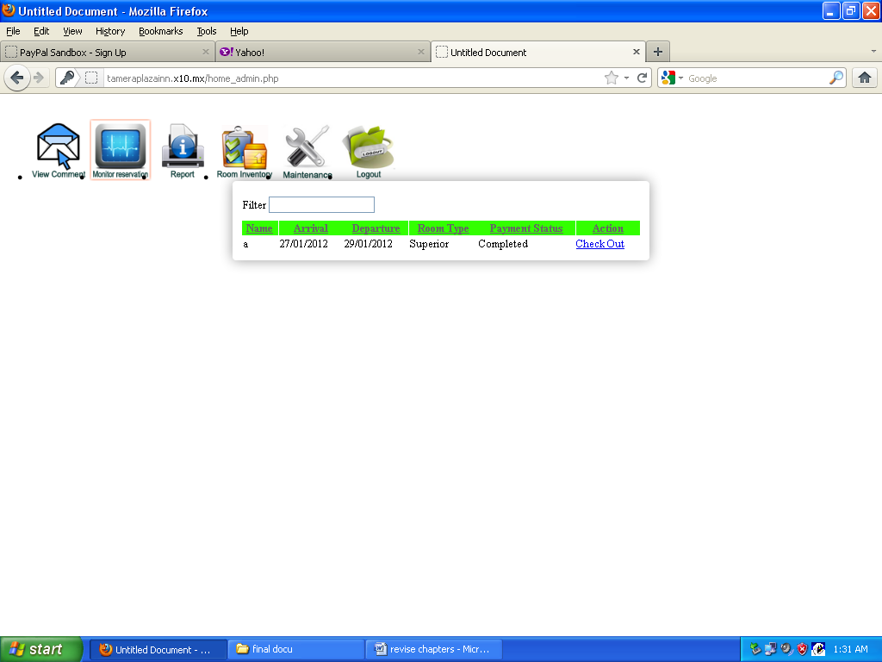

Figure 22. Monitor Reservation

This figure shows that the administrator can monitor the reservation of their guests. This form shows the name of the guest, arrival and departure dates, room type, no. of nights stay and the action that the administrator can be made.

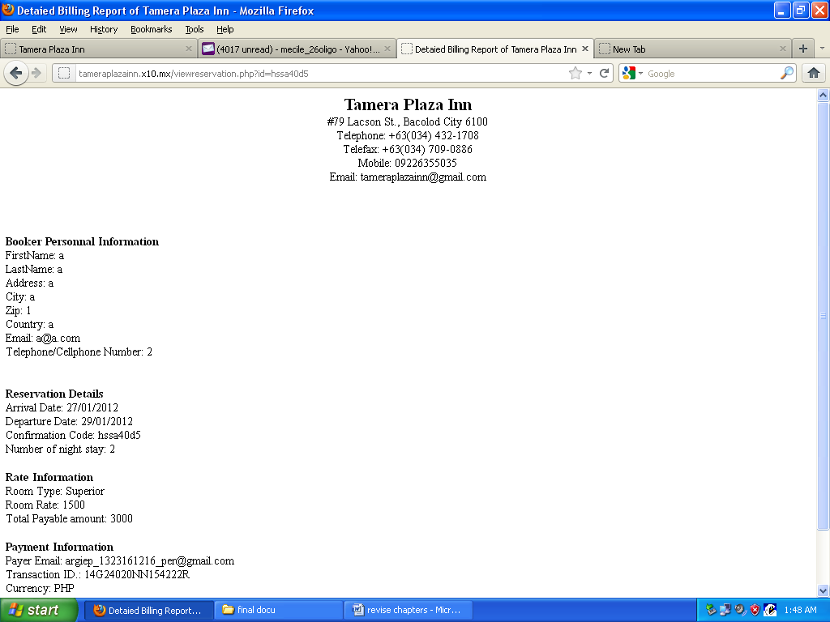

Figure 23. Generate Reports

The figure below shows the reservation details of the guest.

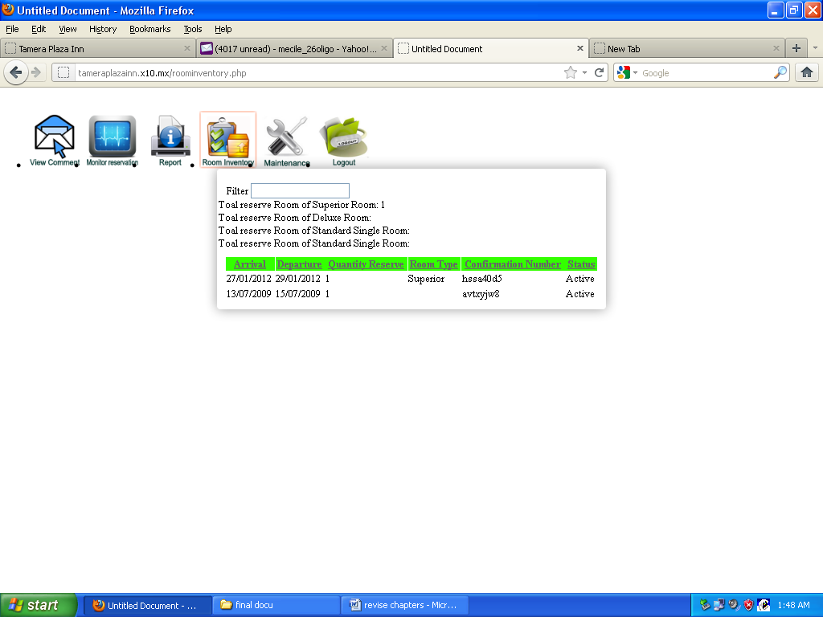

Figure 24. Room Inventory

The figure show the room inventory which define as the arrival and departure dates, quantity of room, room type and status of room.

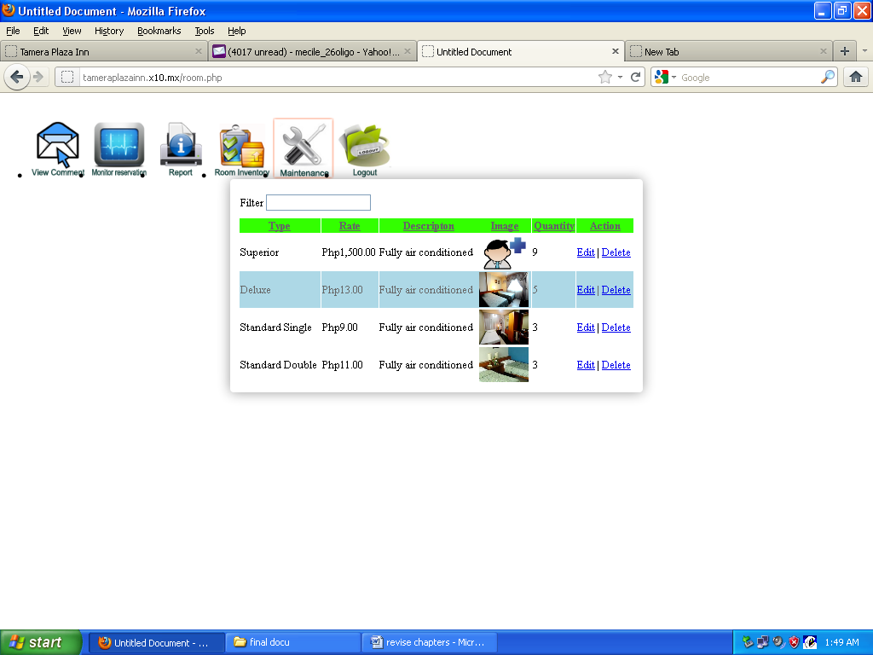

Figure 25. Add or Edit Rooms

In this form the administrator can edit, add and delete a room.

# Chapter V

# Summary Conclusion and Recommendation

This chapter discusses the summary of the entire proposed study wherein the researchers have recommendation according to their findings.

**Summary**

Online Hotel Reservation System has the entire dynamic features which is necessary to manage a hotel or any paid lodging house business. Online Reservation offers an operational integration between reservations, guest history, reception/front desk and the generation of report. The system has a capability to generate report, analyzes booking, and check in check out status.

**Conclusion**

In developing the system, the researchers went through a series of processes in order to furnish meaningful and reliable software to meet the customer’s expectations. After undergoing several processes and observations the researchers had identified the following problems with regards to the reservation processes of Tamera Plaza Inn. The manual processing of reservations and difficulties in retrieving customer’s reservation information are some problems being encountered by the company due to lack of automation in their business transactions. These problems were made possible to formulate a solution that would improve the needs of online customers.

To augment security for the management, lessen time consuming in making reservations and having well suited reservation transactions for the management and customers. The researchers believed that the proposed Online Hotel Reservation System can help and increase companies’ production which is greatly affected by the defined solutions.

**Recommendation**

After conducting and analyzing of the flow of the current system of the Inn, the researchers have the following recommendation.

The use of the system proves to be fast in terms of retrieving and cancelling guest reservation information. The system is accurate to generate detailed reservation report. Convenient to make an online reservations and reliable in securing customers information’s for the process of reservation. The system could save time and lessen effort in recording and monitoring guest reservation processes.

The system could improve the service in any transaction processes and effectively provide accurate data for the customers. This system improves the development of the company for a better and more competitive one. Thus the system can give a very important role to the company in achieving the goals of Tamera Plaza Inn for brighter future.

**References**

(2009, June 13). Retrieved January 9, 2010, from Althos: http://www.billingdictionary.com/billing_dictionary_billing_system_definition.html

(2010). Retrieved from Circle Inn Hotel: http://www.circleinnph.com/

(2012, July 19). Retrieved May 12, 2012, from East View Hotel: http://www.tripadvisor.com/Hotel_Review-g298464-d1755959-Reviews-East_View_Hotel-Bacolod_Negros_Island_Visayas.html

Baldwin, K. (2011). Retrieved from Fairmont Peace Hotel: http://www.fairmont.com/peacehotel

Barr, N. (2012). Retrieved from Constance Moofushi Resort Maldives: http://www.moofushiresort.com/

Farlex. (2004, December). Retrieved from http://www.thefreedictionary.com/privacy-policy.htm

Hotel Booking System. (2006). Retrieved 2012

Jelloun, T. B. (2011). Retrieved from Banyan Tree Resort: http://en.wikipedia.org/wiki/List_of_authors_by_name:_B

Kendall, K. E. (2002). Retrieved from System Analysis and Design: dl.acm.org/citation.cfm?id=579143

Murcko, T. (2009, April 7). Retrieved September 19, 2010, from business dictionary.com: http://www.businessdictionary.com/disclaimer.php

Online hotel reservations. (2010, May 27). Retrieved October 18, 2011, from Wikipedia: http://en.wikipedia.org/wiki/Talk:Online_hotel_reservations

Precision Quality Software, Inc. (2003). Retrieved 2011

wikipedia. (2012, January 30). Retrieved from http://en.wikipedia.org/wiki/System_context_diagram

**APPENDICES**

**Appendix “A”**

**Letter to Respondents**

December 3, 2011

Sir/Madam:

Good day!

The undersigned is a candidate for the degree Bachelor of Science in Information System at Carlos Hilado Memorial State College, Talisay City, Negros Occidental.

The title of the Capstone Project is “Online Hotel Reservation System for Tamera Plaza Inn” Its purpose is to assess the overall function of the system.

The System Evaluation Form is very brief and will take about less than three minutes. But before checking the instrument, the proponents suggest to try the system’s operation. The undersigned would appreciate it if you could complete the System Evaluation Form that represents the acceptability of the system.

The undersigned assures you that all information you provide will be kept strictly confidential. Your name or other identifying information will not appear on any study report. All results from this study will be reported as statistical summaries only.

Please, do not hesitate to call the proponents at +639 or by sending email at jags_720@gmail.com if you have any questions or concerns about the questionnaire. Your participation represents a valuable contribution in the success of achieving the goals and objectives of this study.

Thank you for your precious time and cooperation. God bless.

Sincerely yours,

**Julie Ann Gutierrez**

**Mecile Oligo**

**Argie Policarpio**

**Appendix “B”**

**System Evaluation Form**

Title of the Project : Online Hotel Reservation System

Project Proponent : Julie Ann Gutierrez, Mecile Oligo and Argie Policarpio

Evaluator : ________________________________________

Affiliation : ________________________________________

Date Evaluated : ________________________________________

Instruction: Kindly check one box for each time that rate or evaluate the appropriateness of the questionnaire attached herewith using the twenty-four criteria for software quality using McCalls’ standards.

Score Rate Interpretation

5 Very High

4 High

3 Average

2 Low

1 Very Low

|  |  |  |  |  |  |
| --- | --- | --- | --- | --- | --- |
| **Criteria** | **5** | **4** | **3** | **2** | **1** |
| **1. Auditability** – keeping the record of standard so that you can locate the origin of specific features that appears on reports. |  |  |  |  |  |
| **2. Accuracy** – meeting the user’s need and having a clear statement of what is required. |  |  |  |  |  |
| **3. Commonality** – the degree to which standard, interfaces, protocols and bandwidth are used. |  |  |  |  |  |
| **4. Completeness** – building a representation of requirements that can be accessed of correctness and consistency. |  |  |  |  |  |
| **5. Conciseness** – the compactness of the programs in terms of line of code. |  |  |  |  |  |
| **6. Consistency** – a sound structure which is free from logical defects. |  |  |  |  |  |
| **7. Observability** – system states and variables are visible or queriable during execution, all factors affecting the output is visible. |  |  |  |  |  |
| **8. Operability** – the ability of the system to operate with almost no downtime. |  |  |  |  |  |
| **9. Security** – referring to the availability of mechanism that control or protect programs and data. |  |  |  |  |  |
| **10. Self-Documentation** – as the degree to which the source code provides meaningful documentation. |  |  |  |  |  |
| **11. Simplicity** – the degree to which the program can be understood with less difficulty. |  |  |  |  |  |
| **12. Software System Independence** – degree to which the program is independent of nonstandard programming language features, operating systems characteristics, and other environmental constraints. |  |  |  |  |  |
| **13. Traceability** – the ability in tracing a design representation or actual program component back to requirements. |  |  |  |  |  |
| **14. Training** – as the degree to which the software assists in enabling new users to apply the system. |  |  |  |  |  |
| **15. Controllability** – defined as an exercise of authority or dominative influence. |  |  |  |  |  |
| **16. Data Commonality** – an attribute of the software that provides the use of standard data representations and structures. |  |  |  |  |  |
| **17. Decomposability** – as a large entity separated into component or basic units. |  |  |  |  |  |
| **18. Error Tolerance** – the ability of the system to repair any damage data. |  |  |  |  |  |
| **19. Exception Efficiency** – an attribute of software that provides for minimum execution processing time without decrease in functionality. |  |  |  |  |  |
| **20. Expandability** – the degree to which the system can be modified or improved. |  |  |  |  |  |
| **21. Generality** – the breadth of potential application of program components. |  |  |  |  |  |
| **22. Hardware Dependence** – having a free hand over the way in which the system is implemented. |  |  |  |  |  |
| **23. Instrumentation** – user defined functions which the agent calls at a different time. |  |  |  |  |  |
| **24. Modularity** – a mechanism for splitting software into dependent modules and grouping together items that have some mutual affinity. |  |  |  |  |  |

_____________________________________

**Evaluator signature over printed name**

## Date: __________

**Appendix “C”**

**Permission Letter to the Company**

Tamera Plaza Inn

#79 Lacson Street

Bacolod City

6100

Greetings!

We are the fourth year Bachelor of Science in Information System students of Carlos Hilado Memorial State College – Talisay City and we are currently developing a system project study as a requirement of our course.

In this connection, we would like to seek approval from your good company to allow us to conduct the project study entitled “ONLINE HOTEL RESERVATION SYSTEM FOR TAMERA PLAZA INN”.

Furthermore, we would like to ask your permission to allow us to conduct the following:

1. Interview authorized personnel concerned for the information needed for this project.
2. Take pictures to be used in the website design of the said system.

Your positive response will be highly appreciated. Rest assured that all information gathered will be kept with utmost confidentiality.

Thank you very much and God Speed.

Sincerely yours,

**Julie Ann C. Gutierrez**

**Mecile H. Oligo**

**Argie L. Policarpio**

**Appendix “D”**

**Interview Questionnaire**

**Online Hotel Reservation System for Tamera Plaza Inn**

**Direction:** Please answer the following questions with honesty. Rest assured that information will be kept confidential.

1. Who is the owner of the company?

_________________________________________________________

1. How many rooms does your hotel have?

_________________________________________________________

1. What are the other amenities of the Tamera Plaza Inn?

_________________________________________________________

_________________________________________________________

1. Who are your target markets?

_________________________________________________________

_________________________________________________________

1. What are the modes of payment?

_________________________________________________________

_________________________________________________________

1. What is your existing system?

_________________________________________________________

1. What are the common problems encountered in using the existing system?

_________________________________________________________

1. Are you willing to adopt the proposed system?

_________________________________________________________